Laboratory 02

Jeffrey Daniel Leiva Cascante
Tamara Nicole Rodríguez Luna
Computer engineering department, Tecnológico de Costa Rica
IC4301 – Databases I
Teacher: Msc. Adriana Álvarez Figueroa.
September 09th 2022.

In this document are the evidence of laboratory 02 where you can see the objects
created, data inserted, modified, among others.
Evidences:
- Register 20 people with legible and consistent data that includes salary data,
names and surnames, date of birth, among other basics. Make sure there are 10
people who have the highest salaries and that 5 of those salaries are repeated.
- In this image you can see the table Person in the Database empty:
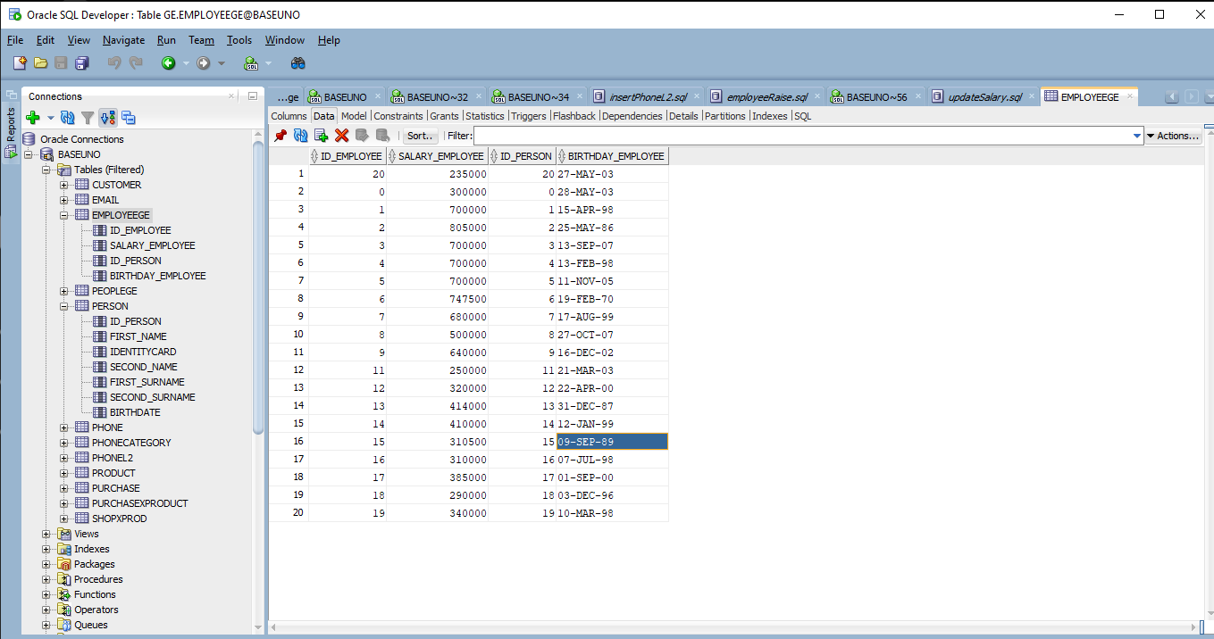
- In this image you can see the table Person in the Database with 20 people registered but without the salary, because for our ER we need to insert that later:
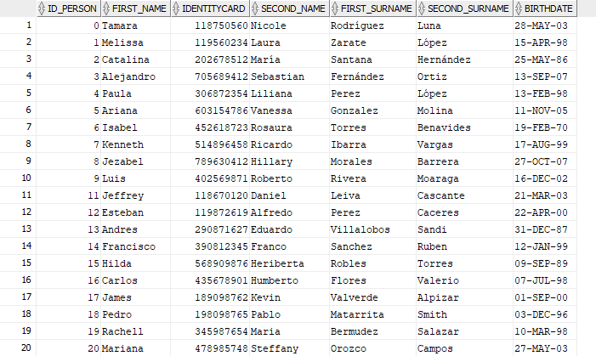
- In this image you can see the table employeege in the Database empty:
o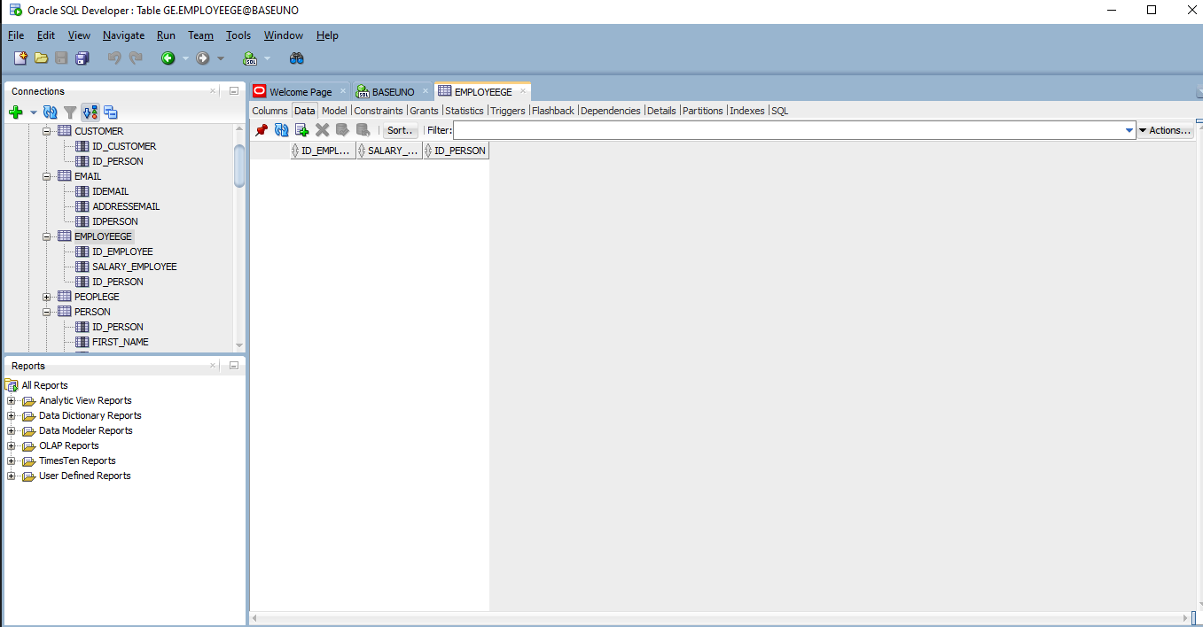

- In this image you can see the table employeege in the Database with 20 employees registered but with the salary:
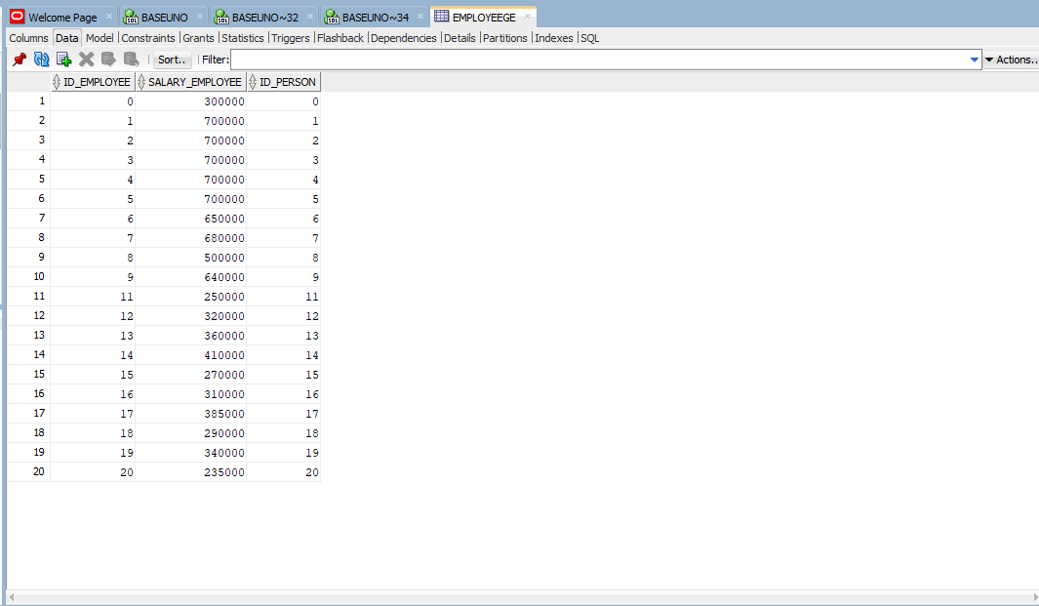
- Delete one person.
- In these images you can see the table Person in the Database before the delete:
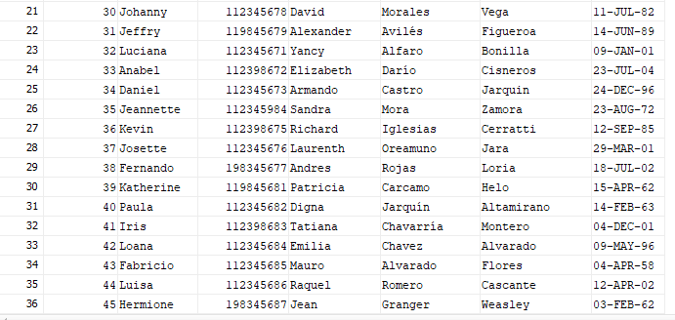

- In this image you can see the table Person in the Database after the delete:
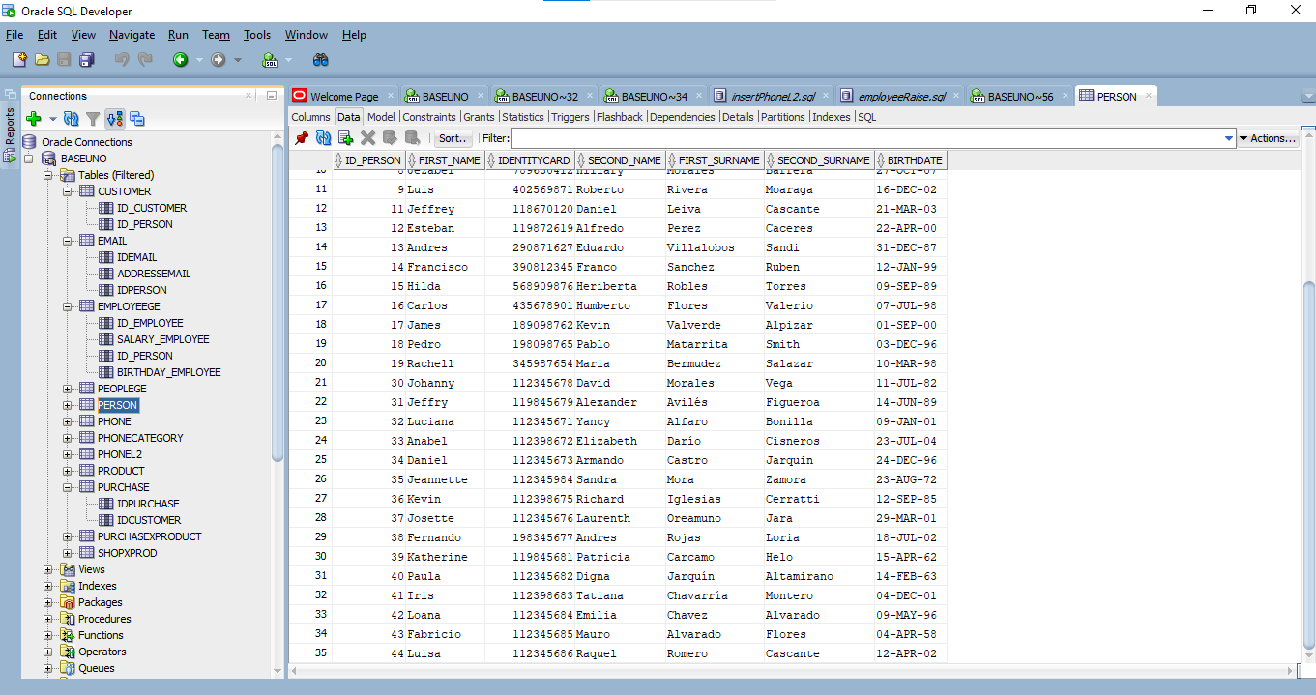
- Register 8 phones with phone type including 'Casa', 'Celular', 'Oficina' and model so that more phone types can be included.
- In this image you can see the table phone in the Database empty:
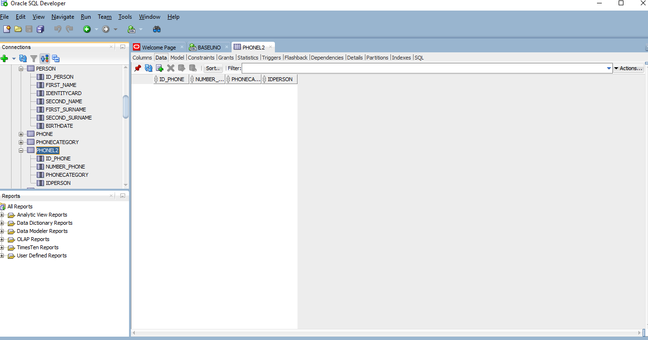

- In this image you can see the table phone in the Database with 8 registers:
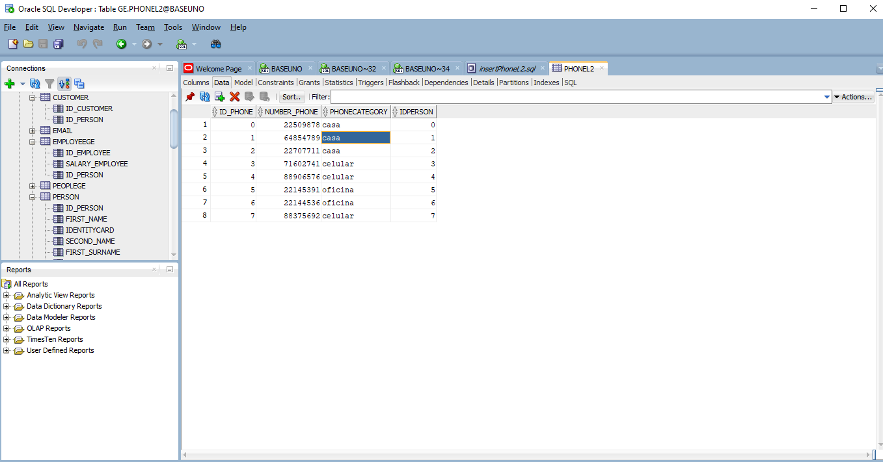
- Delete one phone:
- In this image you can see the table phone in the Database before the delete:

- In this image you can see the table phone in the Database after the delete:
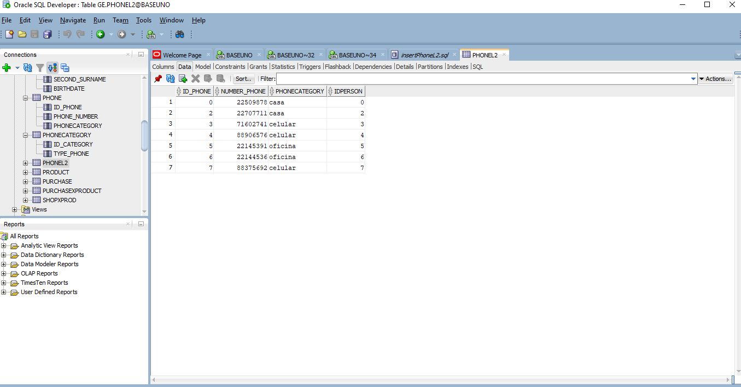
- Delete a person who has associated phones. What's going on? Justify your response.
- In this image you can see the error that occurred while when we were trying to eliminate a person with associated telephones, because if the database gives us the possibility to do so, the telephone will be left loose without having a person to whom it belongs and would be to have 'data floating' in our system.
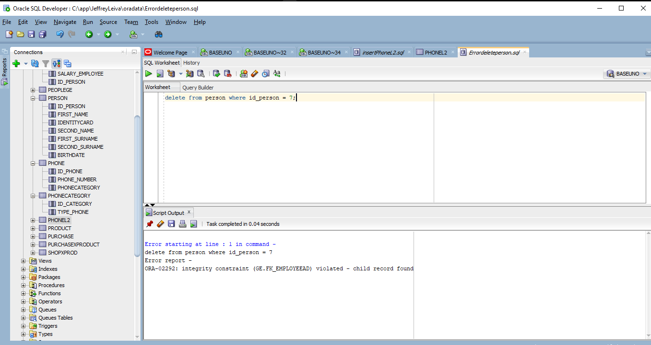

- Update a person to change her name to 'Marcela'.
- In this image you can see the table person in the Database before the change:
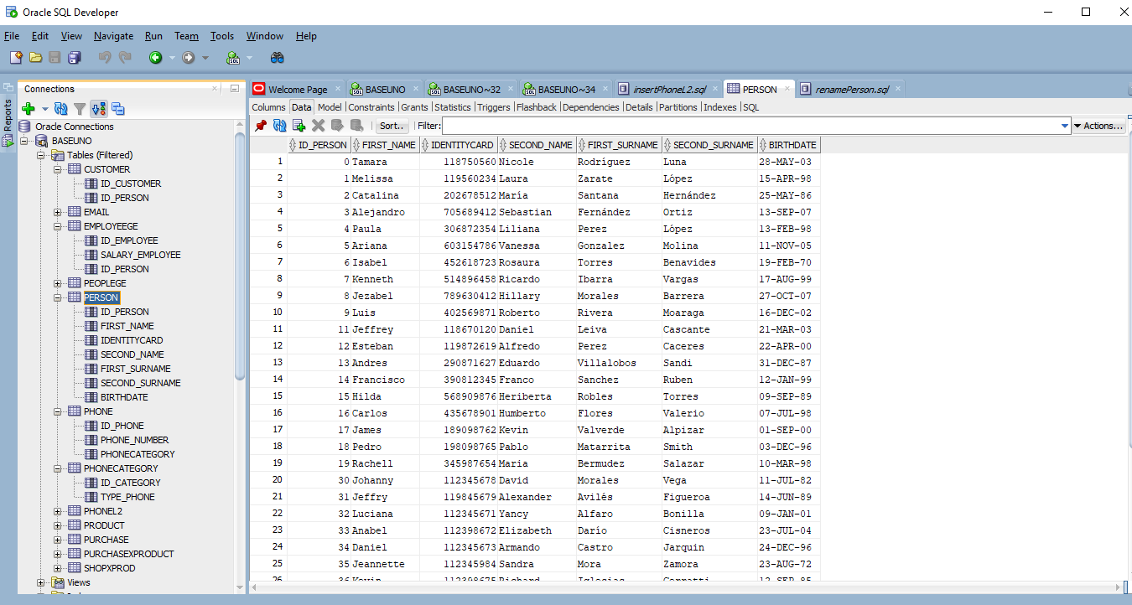
- In this image you can see the table person in the Database after the change:
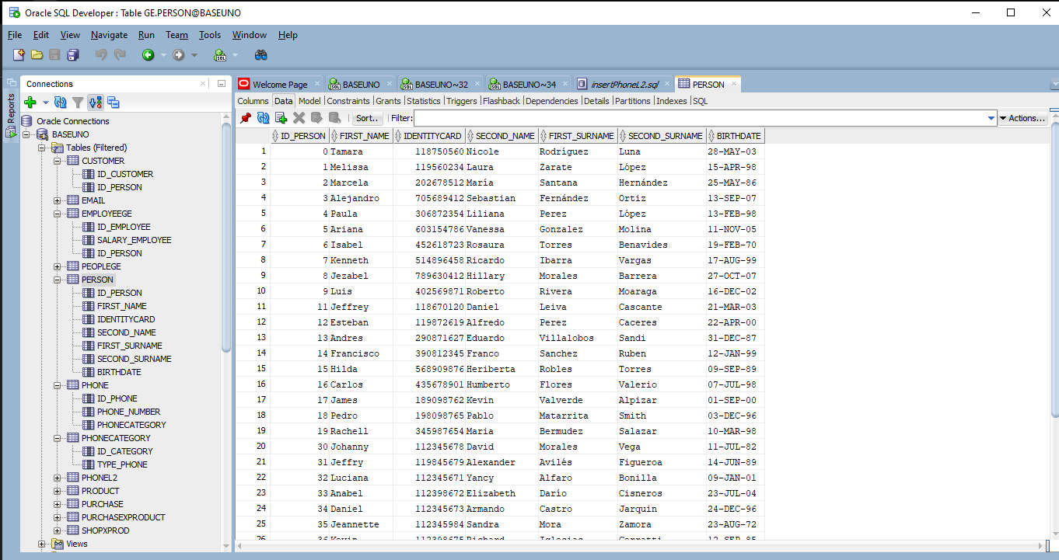

- Update a phone type to rename it to ‘Celular’.
- In this image you can see the error that occurred while we tried to update a type of phone and rename it to cell phone, because if the database gives us the possibility to do so, the already existing category called cell phone would be overwritten and would have a problem of data integrity since when called the same we would not know what type we are referring to. It would cause many problems when making queries and for the people who manage the data, they will not know what type to enter the data, also allowing repeated data.
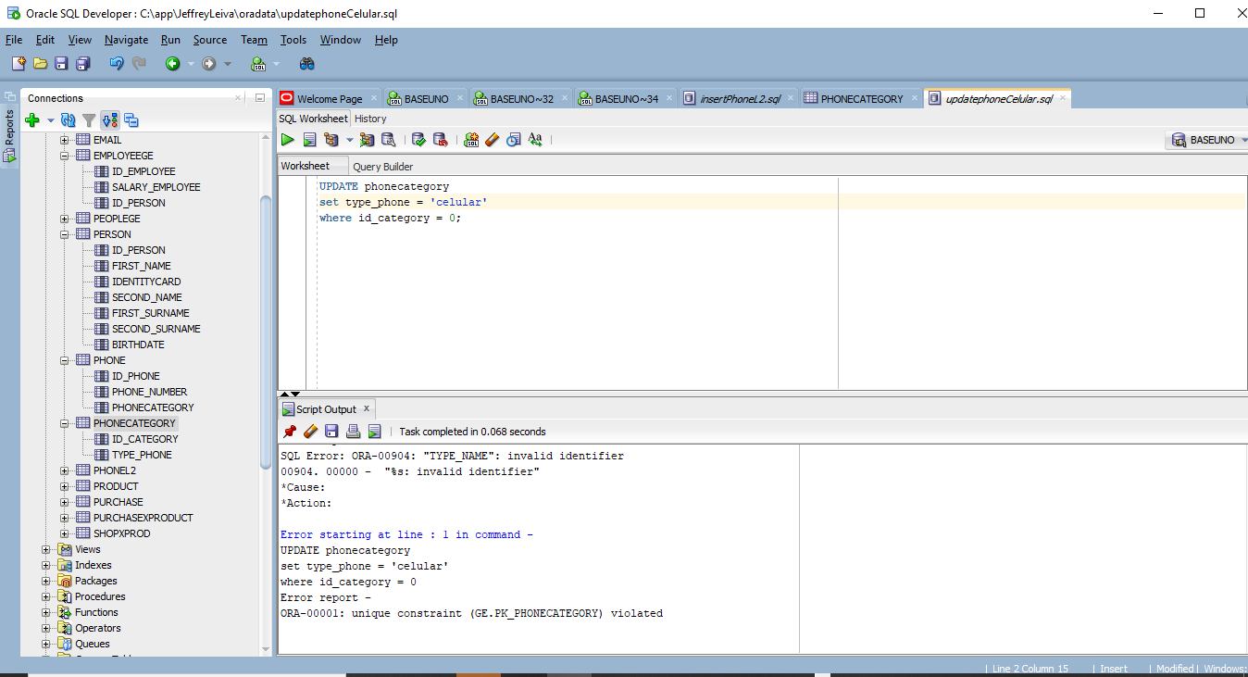
- Increase the salary by 15% to people who are over 30 years old.
- In this image you can see the table employeege in the Database with 20 employees registered but without the increase in the salary 15% to people who are over 30 years old:
- In this image you can see the table employeege in the Database with 20 employees registered but with the increase in the salary 15% to people who are over 30 years old:
- Assign 15 people to be customers.
- In this image you can see the table customer in the Database empty:
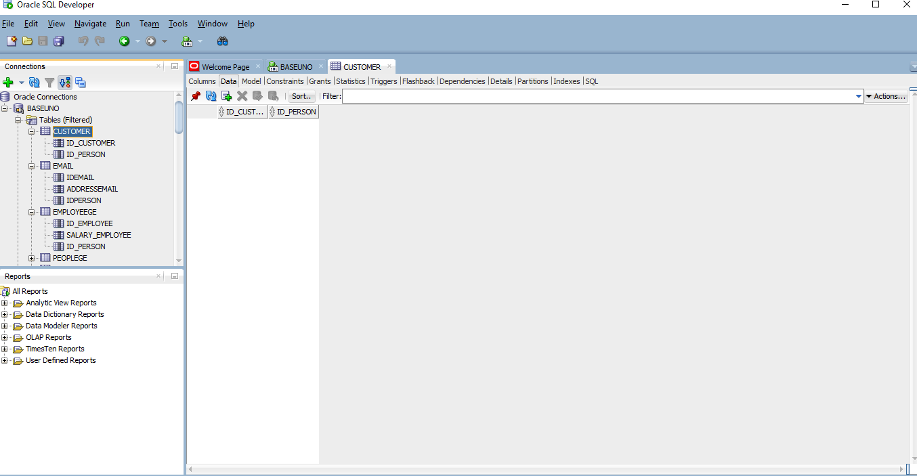
- In this image you can see the table customer in the Database with 15 customer registered:
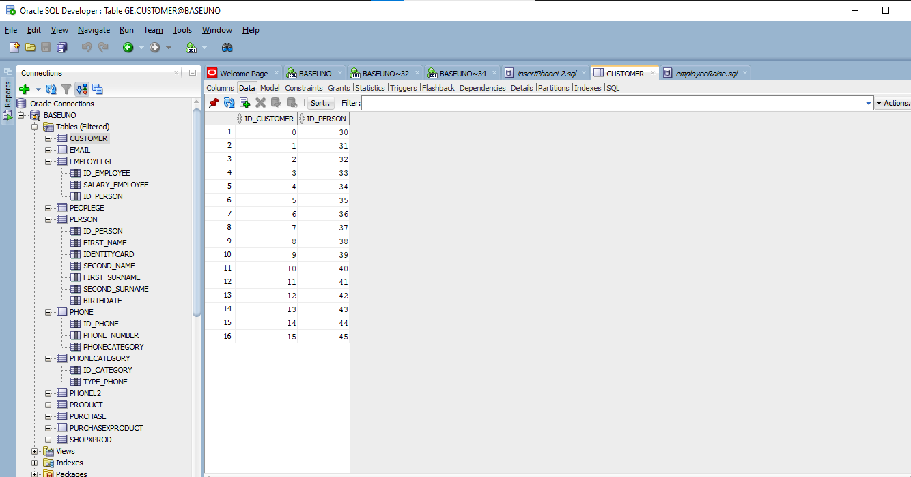

- Create 15 products.
- In this image you can see the table product in the Database empty:
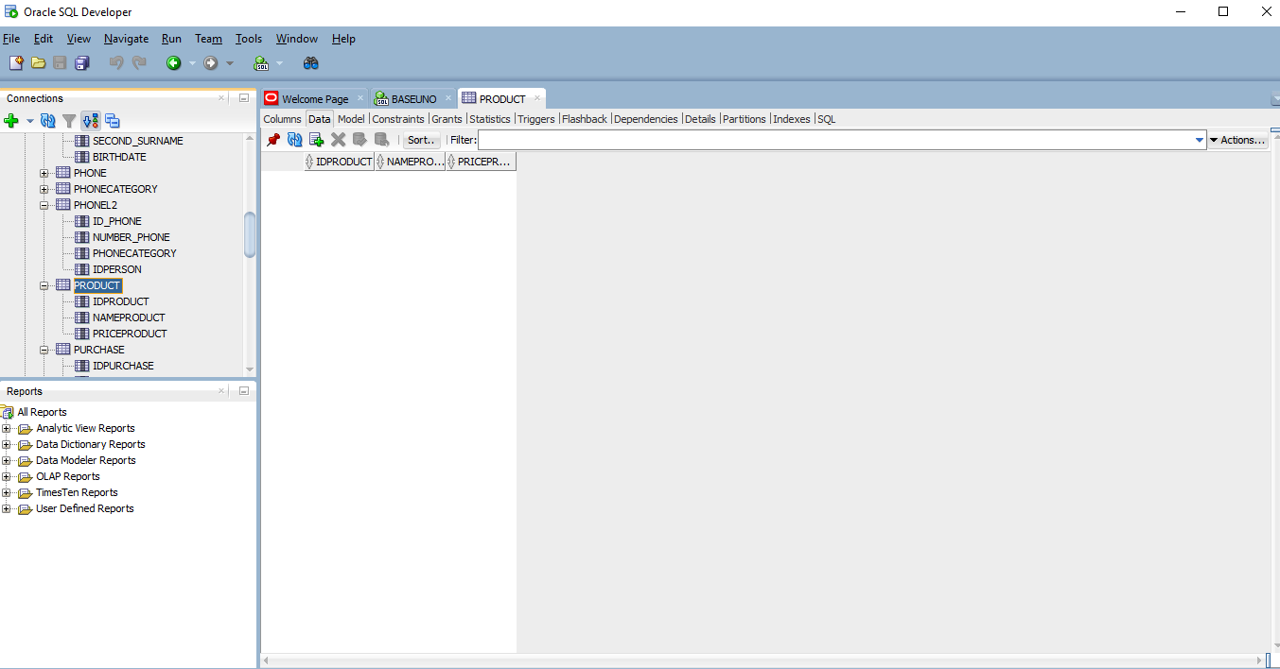

- In this image you can see the table customer in the Database with 15 products created:
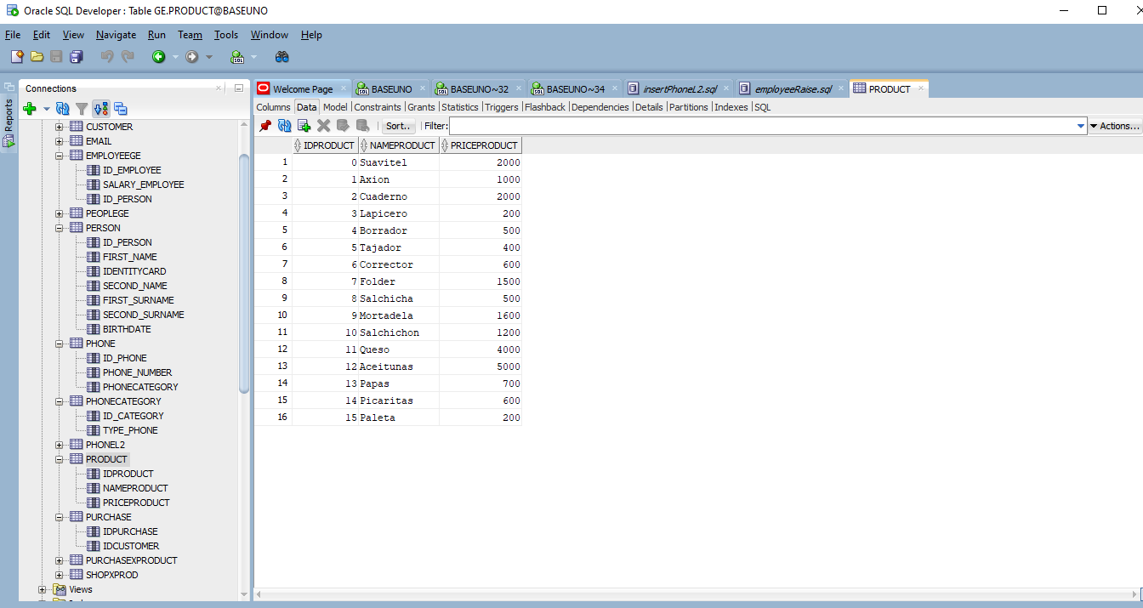
- Create purchases for 7 customers. At least 5 of them must have more than 2 purchases and more than 1 product per purchase.
- In these images you can see the tables purchase and purchasexproduct in the Database empty:
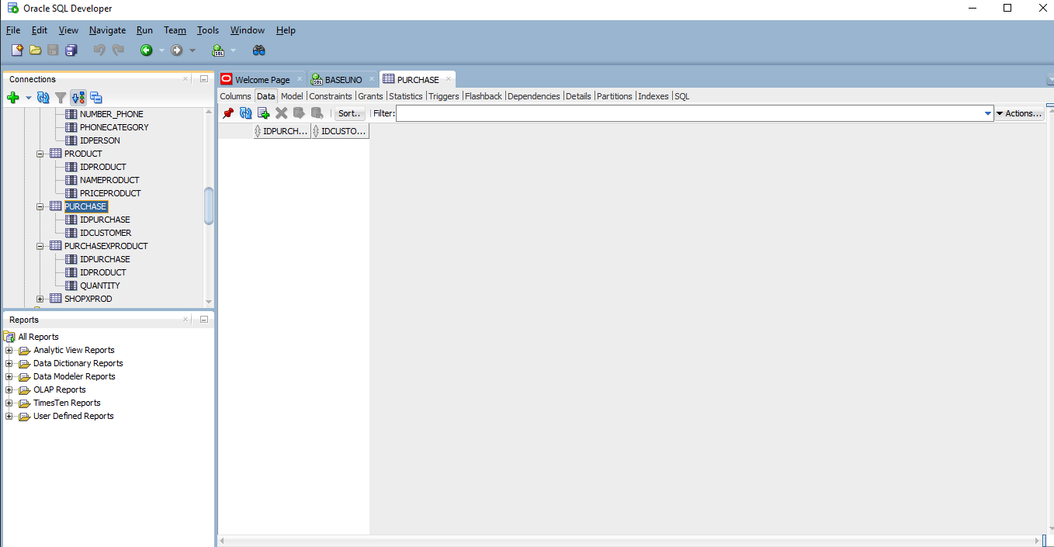
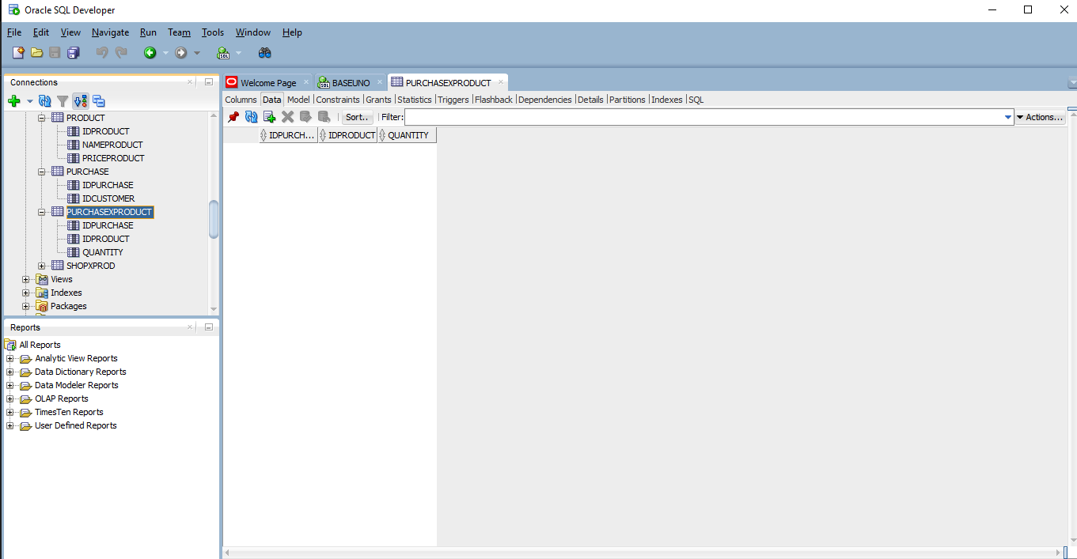
- In these images you can see the tables with the changes:
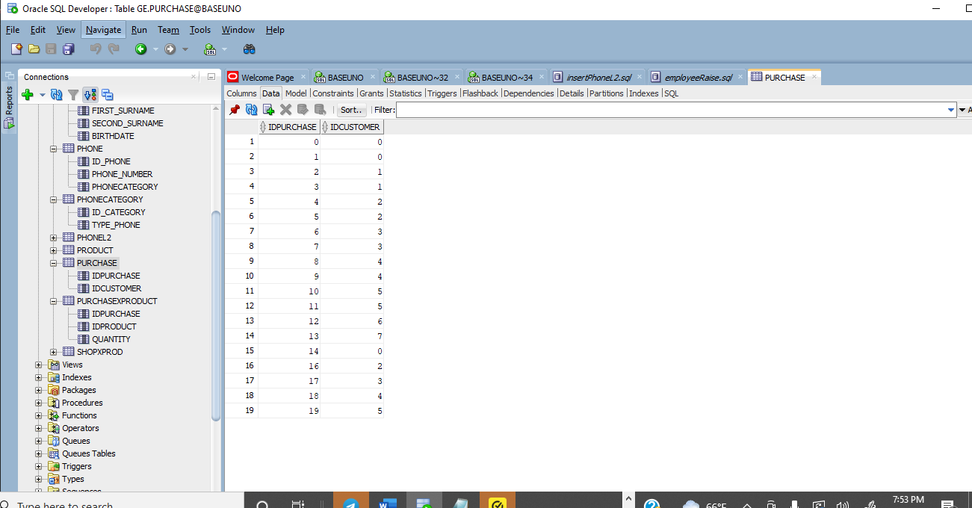
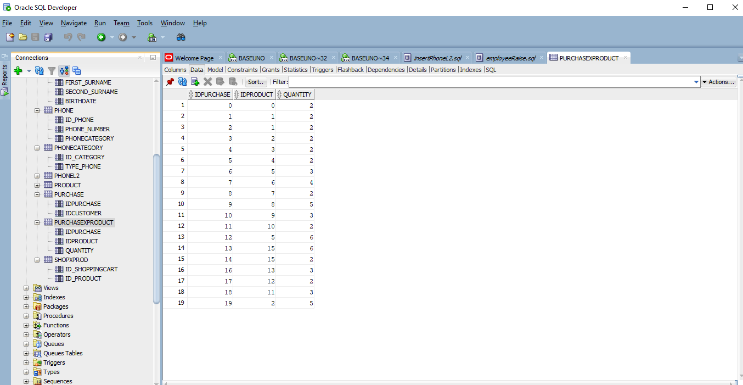

- Change the datatype of a column that already has data. What’s going on?
- In this image you can see the error that occurred while we tried modified a column with data. For this change the column must be empty, it must not contain stored data. In this case we wanted to go from the data type of numbers to text strings and it prevented us, to maintain the integrity of the data already stored and that there is no data out of the ordinary in a column.
